Ideation Phase
Empathize & Discover

Team Details

Date | 18 February 2026
Team ID | LTVIP2026TMID53603
Project Name | HouseHunt: Finding Your Perfect Rental  Home
Maximum Marks | 2 Marks

Empathy Map Canvas

An empathy map is a simple, easy-to-digest visual that captures knowledge about a user’s behaviours and attitudes.

It is a useful tool to help teams better understand their users. Creating an effective solution requires understanding the true problem and the person who is experiencing it. This exercise helps participants consider things from the user's perspective along with their goals and challenges.

User Persona
Alice – A working professional or student relocating to a new city, looking for a verified and affordable rental property.
Bob – A property owner with one or more apartments to rent, seeking an easyto-use platform for managing listings.

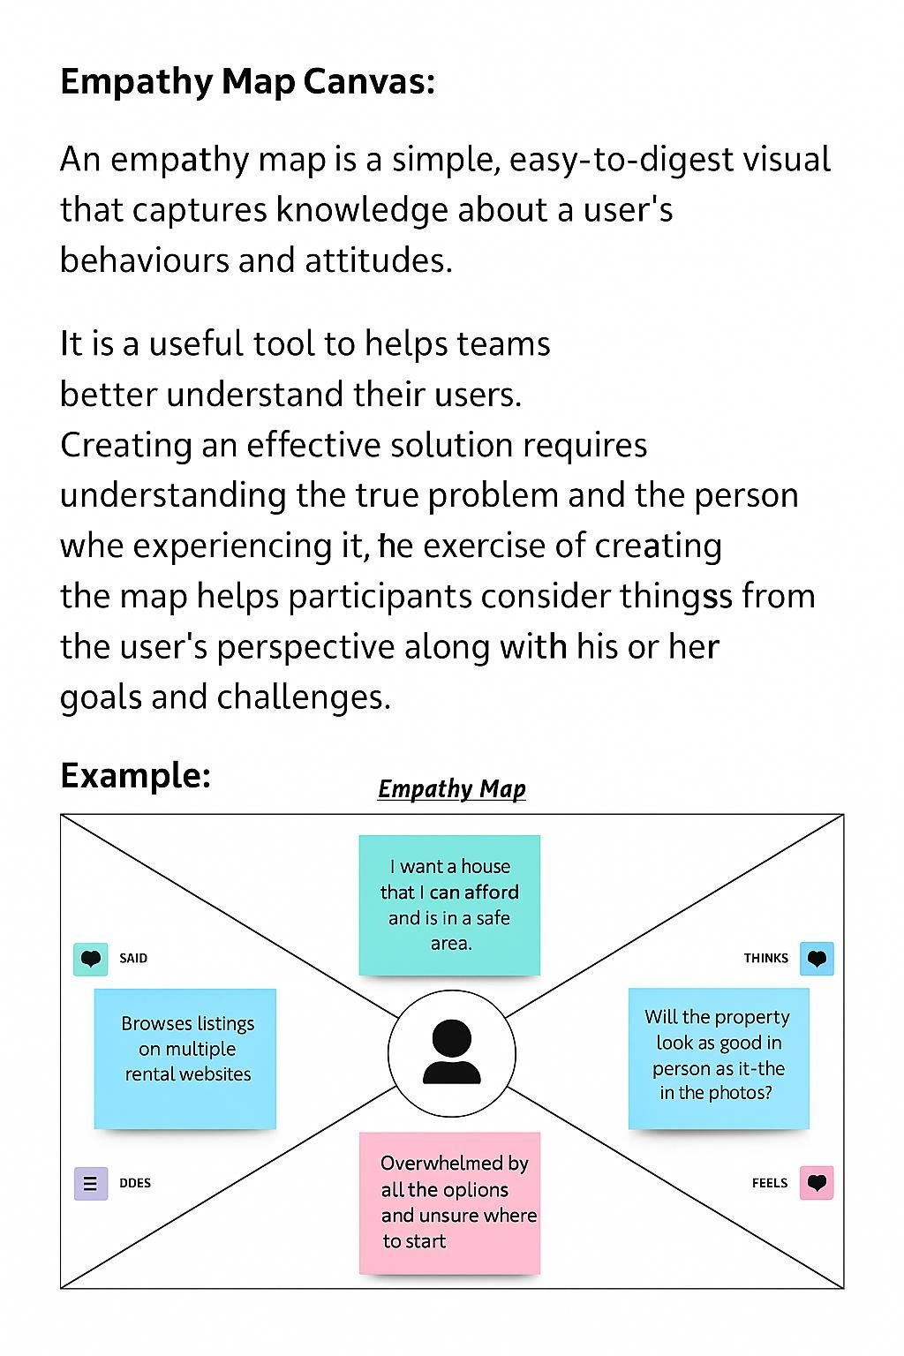

Empathy Map Insights

SAYS | “I want to find a home that matches my needs without going through agents.” “Posting and managing my rental listings should be simple.”
THINKS | “Is this property genuine and available?”  “Can I trust this platform and the person I’m renting from/to?”
SEES | Outdated listings, complex filters, and inconsistent details on other platforms.
HEARS | From peers: 'Be careful of scams online.'  From other owners: 'Listings often go unanswered.'
DOES | Uses filters to browse listings.  Posts and updates property details. Checks booking status and responds to inquiries.
PAIN | Fear of scams or hidden fees. Delayed or no response from owners/renters.  Limited verification of properties or users.
GAIN | Verified listings and user profiles.  Booking notifications and tracking. Easy dashboard for listing management.

